***Integrated Gulf of Mexico Bird Monitoring Framework***

***Structured Decision Making Prototype Version 3.0***

***Draft Interim Technical Report – October, 2015***

***A Product of the Gulf of Mexico Bird Monitoring Working Group***

***Edited by:***

***Randy Wilson***

***U.S. Fish and Wildlife Service, Migratory Bird Program***

**INTEGRATED GULF OF MEXICO BIRD MONITORING STRATEGY**

**-- DRAFT SDM PROTOTYPE VERSION 3.0 --**

# DECISION PROBLEM

Over the years, the conservation community comprised of dedicated scientists and conservationists ranging from on the ground habitat managers and researchers to those making programmatic, region-wide funding allocations have done an admirable job of monitoring the “species/topic du jour”; usually in the form of a research project. However, the conservation community continues to struggle to design and implement a large-scale, coordinated monitoring program due to the complexity of the Gulf of Mexico System (e.g., multiple priority bird species using different habitats during different times of the year [breeding season vs. migration]). This issue is further complicated by the need for both surveillance-based (e.g., baselines, trends) and outcome-based (e.g., response to management) monitoring. To address the reoccurring question of what and where to monitor, the conservation community needs to engage in a structured process to identify information needs and priorities of a coordinated bird monitoring strategy that addresses multiple objectives, species, and habitats along the Gulf of Mexico, such that operational and financial decisions can be made in a proactive and adaptive manner. To that extent, we developed the following problem statement: *“how do we develop a cost-effective monitoring strategy for the Gulf Coast avian community/Gulf Coast ecosystem that evaluates on-going, chronic, and acute threats and conservation activities, maximizes learning, and is flexible and holistic enough to detect novel ecological threats with respect to management triggers and to evaluate new and emerging conservation activities?”* To address this problem statement, a group of conservation partners (representing a variety of agencies and organizations) with interest in the Gulf of Mexico participated in a Structured Decision Making Workshop at NCTC with the objective of utilizing the principals of decision analysis to identify a structured process for developing and implementing a bird monitoring strategy across the Gulf of Mexico to better inform conservation actions.

# BACKGROUND

## Legal, regulatory, and political context

At this point, there are no legal, regulatory or political underpinnings to the implementation of a bird monitoring strategy in the Gulf of Mexico, per se. However, several Federal and State Wildlife Agencies have legal mandates to protect and conserve wildlife resources and their habitats for the continuing benefit of the American people. Hence, the success of designing and implementing a coordinated and collaborative monitoring strategy for the Gulf of Mexico requires the commitment and dedication of a wide array of conservation partners (e.g., Federal Agencies, State Wildlife Agencies, NGOs, Joint Venture Partnerships and Landscape Conservation Cooperatives), all operating under different mandates and missions.

## Ecological context

Birds are a conspicuous and remarkable natural resource of the Gulf of Mexico. Hundreds of species and millions of individual birds are supported by barrier islands, beaches, marshes, and coastal forests across the Gulf ecosystem. Collectively, these species are an unparalleled indicator of system health and the natural resources on which humans rely for their health, economy, and quality of life. Today, the conservation of coastal habitats for birds is often at odds with human population growth, creating tension between the importance of coastal areas for human needs and their value for birdlife. Anthropogenic stressors (e.g., oil spills, urban development) along with more natural disturbances (e.g., hurricanes, sea level rise) can result in loss, fragmentation, and reduced quality of habitats in sensitive coastal ecosystems. Quantifying the magnitude of these impacts, as well as assessing bird/habitat response to mitigation and restoration activities is critical, if the conservation community is to work in a collaborative, proactive-manner to protect and conserve valuable natural resources along the Gulf Coast.

# DECISION STRUCTURE

The core of Structured Decision Making (SDM) is a set of well-defined objectives and evaluation criteria. Together they define “what matters” about the decision, drives the search for creative alternatives, and becomes the framework for comparing alternatives (Gregory et al. 2012). To initiate discussions per identification of monitoring objectives, a group of scientist representing a myriad of conservation partners (see table x) across the southeast met numerous times over the last 12 months to identify and articulate bird monitoring objectives and associated value models for the Gulf of Mexico using the principles of SDM guide their decision making.

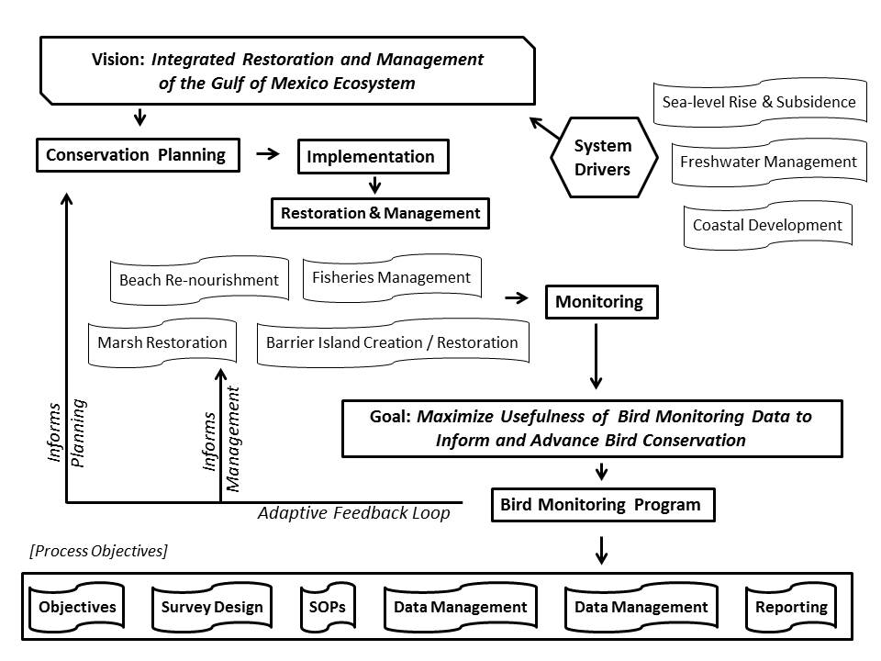To clearly examine and define fundamental objectives for avian monitoring, the group undertook a “stakeholder brainstorming session” where each person was asked to list the core values and/or needs they deemed necessary for underpinning bird monitoring efforts in the Gulf of Mexico. From this exercise, several key concepts repeatedly emerged – scientific rigor; relevancy; state of the system; response to management; integration; and partnerships. From here we developed an influence diagram that linked monitoring to the larger fundamental objective of restoring the Gulf of Mexico and providing direct linkages to ongoing conservation planning efforts (Figure 1) which permitted us to think about fundamental objectives in a new light (i.e., do our fundamental objectives serve as means objectives for achieving the overarching vision of integrated restoration and management?). Additionally, the influence diagram identified the “process objectives” which will need to be addressed in the development of bird monitoring strategy including several embedded components such as data management and communication. The recognition of these process objectives provided additional structure to our thinking allowing us to separate the key components, while at the same time realizing necessary linkages where appropriate. By constructing the influence diagram, the group was able to redirect its thinking to better articulate core values and a set of fundamental objectives that represent these values in a hierarchical format (see below).

Specifically, the fundamental objectives are:

**Objective 1.0**: *Maximize the relevancy of monitoring data within the northern Gulf of Mexico (i.e., ensure monitoring projects are addressing contemporary data needs: status assessment of bird populations and their habitats; understanding system drivers and stressors and the associated mechanisms that impact bird populations; and understanding the positive and negative effects of management actions on bird populations and their habitats).*

**Sub-objective 1.1**: *Maximize our collective ability to conduct population and habitat status assessments (i.e., baseline information related to the status and trends of priority bird species and their primary habitats in the Gulf of Mexico)*

**Sub-objective 1.1.1**: *Status Assessment of Priority Avian Species*

**Sub-objective** **1.1.2**: *Status Assessment of Primary Habitats*

**Sub-objective 1.2**: *Maximize our collective ability to understand ecological processes and their respective impacts on avian populations.*

**Sub-objective 1.3**: *Maximize our collective ability to understand management actions and their respective impacts on avian populations.*

**Objective 2.0:** *Maximize Rigor of Monitoring Projects (increase emphasis on scientific rigor [study designs, sampling frameworks, power analysis, etc.] underpinning monitoring projects in the Gulf of Mexico)*

**Objective 3.0**: *Maximize Integration of Monitoring Projects (increased integration and explicit linkages to monitoring efforts and data needs outlined in Conservation Business Plans)*

Figure 1. Objectives hierarchy for bird monitoring in the Northern Gulf of Mexico

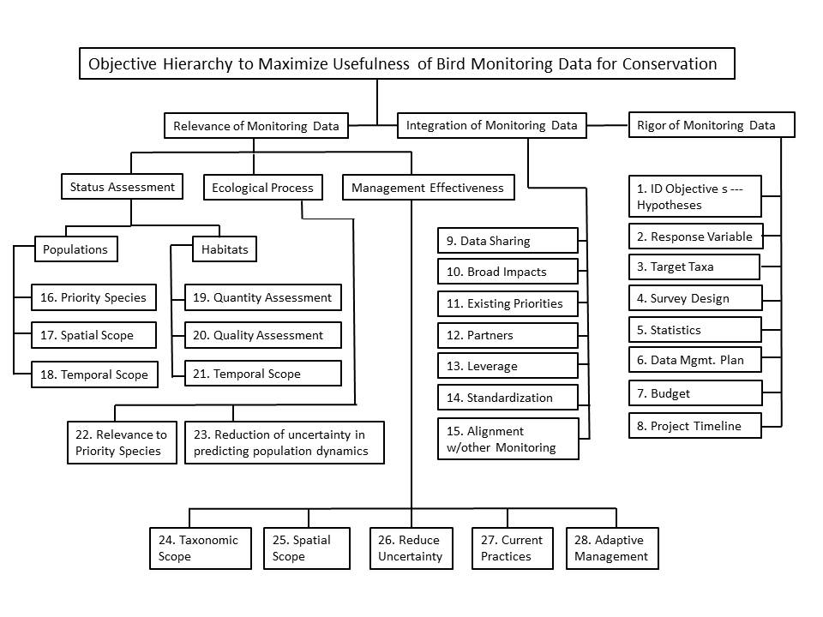**SUB-OBJECTIVES AND PERFORMANCE METRICS**

For each of the fundamental objectives, we articulated a set of sub-objectives and associated performance metrics or evaluation criteria, as they are often referred; to facilitate the evaluation of monitoring objectives and the development of alternatives towards achieving the fundamental objective.

**STATUS ASSESSMENT – SUB-OBJECTIVES**

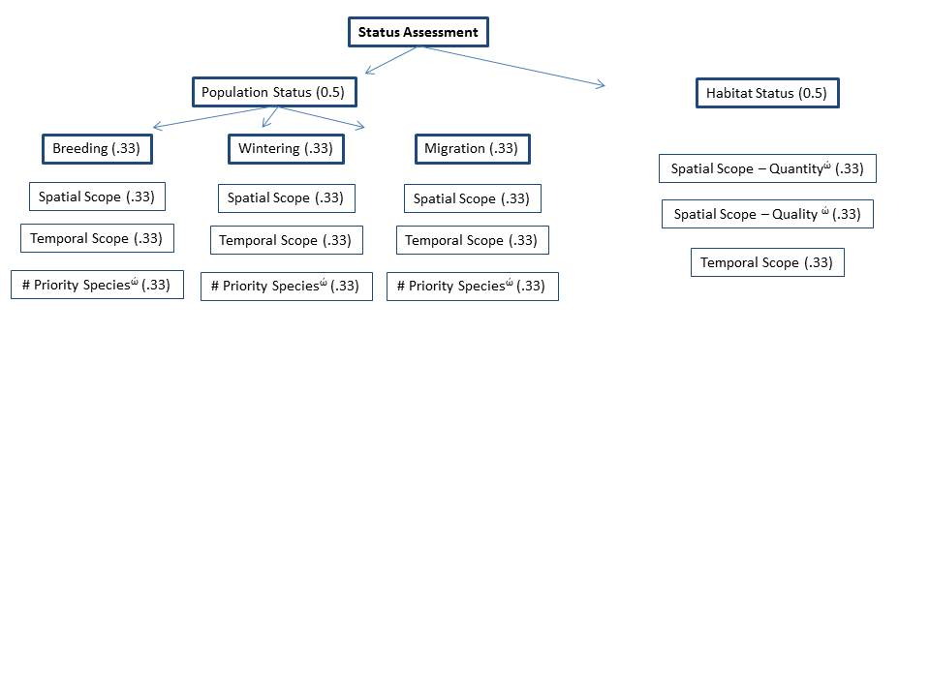

**STATUS ASSESSMENT – PERFORMANCE METRICS (POPULATIONS)**

Because (priority) avian species utilize the Northern Gulf of Mexico during different time periods within a year, thereby necessitating different survey designs, protocols, etc. The population status assessment objective is further divided into three sub-objectives to reflect these time periods (e.g., breeding season, wintering season, and migration [to include both spring and fall migration]). That is, we desire to maximize our understanding of baseline information for priority avian species within each time period. To further our understanding of population status assessments within each time period, three value models were developed will be employed within each of the sub-objectives.

1. Maximize the number of priority bird species surveyed. *Emphasis placed on a survey that incorporates the maximum number of priority species.*

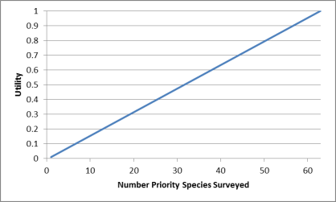0 = no priority bird species surveyed

1 = 1 priority bird species surveyed

2 = 2 priority bird species surveyed

3 = 3 priority bird species surveyed

…….

63 =63 priority bird species surveyed

*ώ = weighted by contribution to conservation needs derived from the scoring of priority species against a set of criteria (see Excel spreadsheet). Weights are based on the mean conservation need value from all priority bird species surveyed; weights derived from value function of species contribution to conservation need based on a constructed scale.*

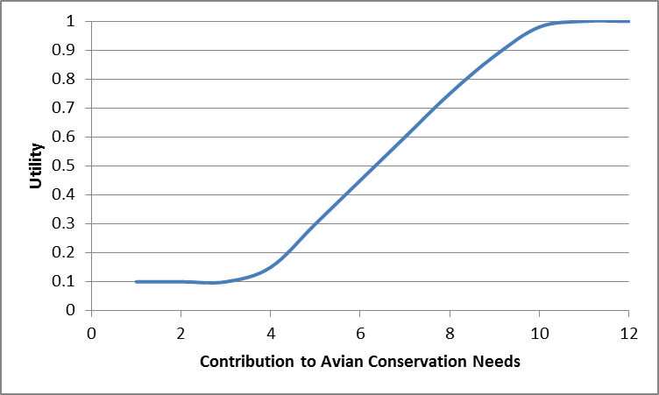

*1 = mean conservation need ≤4*

*2 = mean conservation need 5-7*

*3 = mean conservation need 8-10*

*4 = mean conservation need >10*

*Value=nώ*

*Where n=number of species surveyed and ώ=weight derived from mean conservation need of species surveyed.*

*NEED TO UPDATE THE WEIGHTING SECTION TO REFLECT NEW PROCESS*

1. Maximize the spatial scope of surveys. *Emphasis placed on a survey that incorporates the full range (or average range, if more than one priority bird species is surveyed) during a specific life-cycle period (e.g., breeding, wintering, migration).*

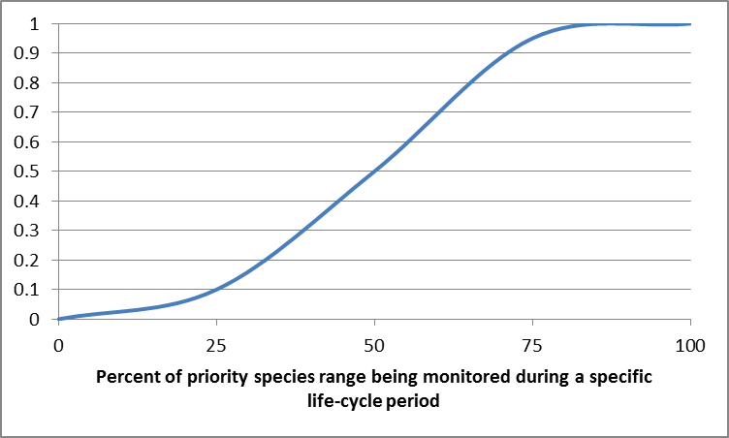 0 = no part of the bird species range is surveyed

1 = <25% of the bird species range is surveyed

2 = 25-50% of the bird species range is surveyed

3 = 50-75% of the bird species range is surveyed

4 = >75% of the bird species range is surveyed

1. 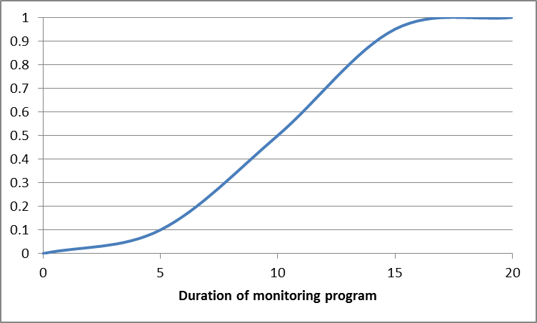Maximize the temporal scope of surveys. *Emphasis placed on a survey that generates data over a long time period. Note – data does not need to be collected every year, but the survey design should address repeated counts at specified time intervals into the future.*

1 = 1 to 4 year longevity

2 = 5 to 10 year longevity

3 = 11 to 15 year longevity

4 = 16 to 20 year longevity

5 = >20 year longevity

**STATUS ASSESSMENT – PERFORMANCE METRICS (HABITATS)**

1. 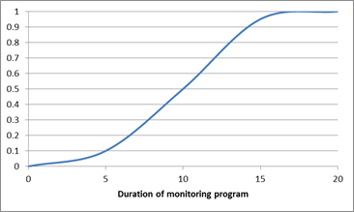Maximize the temporal scope of surveys. *Emphasis placed on a survey that generates data over a long time period. Note – data does not need to be collected every year, but the survey design should address repeated counts at specified time intervals into the future.*

1 = 1 to 4 year longevity

2 = 5 to 10 year longevity

3 = 11 to 15 year longevity

4 = 16 to 20 year longevity

5 = >20 year longevity

1. Maximize the spatial scope of habitat quantity assessments. *Emphasis placed on a survey that collects habitat quantity data (acreage, distribution, number of patches, etc.) and incorporates the full range of the habitat within the Northern Gulf Region.*

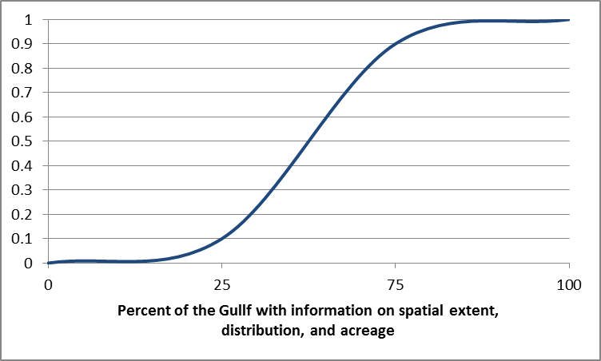

0 = no habitat quantity data collected

1 = habitat quantity data collected on <25% of the habitat’s gulf-wide range

2 = habitat quantity data collected on 25-50% of the habitat’s gulf-wide range

3 = habitat quantity data collected on 51-75% of the habitat’s gulf-wide range

4 = habitat quantity data collected on >75% of the habitat’s gulf-wide range

1. Maximize the spatial scope of habitat quality assessments. *Emphasis placed on a survey that collects habitat quality data (vegetative structure, water quality parameters, etc.) and incorporates the full range of the habitat within the Northern Gulf Region.*

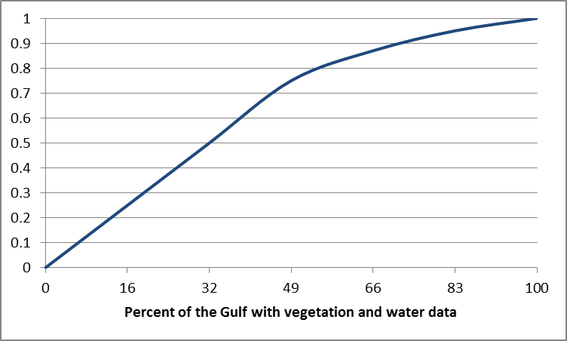

0 = No habitat quality data collected

1 = Vegetation quality or water quality data collected on <25% of the habitat’s gulf-wide range

2 = Vegetation quality and water quality data collected on <25% of the habitat’s gulf-wide range

3 = Vegetation quality or water quality data collected on 25-50% of the habitat’s gulf-wide range

4 = Vegetation quality and water quality data collected on 25-50% of the habitat’s gulf-wide range

5 = Vegetation quality or water quality data collected on 51-75% of the habitat’s gulf-wide range

6 = Vegetation quality and water quality data collected on 51-75% of the habitat’s gulf-wide range

7 = Vegetation quality or water quality data collected on >75% of the habitat’s gulf-wide range

8 = Vegetation quality and water quality data collected on >75% of the habitat’s gulf-wide range

**ECOLOGICAL PROCESSES – SUB-OBJECTIVES**

**INSERT GRAPHIC OF ECOLOGICAL PROCESS OBJECTIVES**

**ECOLOGICAL PROCESS– PERFORMANCE METRICS**

**Problem statement for population drivers:**

Bird populations are sustained by an interplay of basic ecological process, such as climate dynamics, primary and secondary productivity patterns, hydrological processes, formation and maintenance of habitats, interactions between species, movement ecology and natural disturbance. Anthropogenic effects exert their influences on avian populations by affecting these ecological processes. Conserving bird populations therefore depends on the ability to to correctly tally and understand the effects of human-derived influences on the ecological processes affecting birds. This understanding can only be derived through knowledge of the specific influences of basic ecological processes driving specific avian populations. Such a body of knowledge is fundamental to long term management of bird populations generally, but it is also absolutely necessary to interpret effects of specific management actions. Monitoring to understand the ecological drivers of avian populations will generally occur at much larger spatial and time scales (decades, thousands of km2) than those typical of studies designed to monitor specific management actions (years, tens to hundreds of km2). The separation of monitoring avian population drivers and management actions is based on this general difference in time and spatial scales.

**Goal:**

Maximize the ability to discern the degree and mechanism by which ecological processes drive avian populations in the GOM, in order both to interpret population fluctuations, and to correctly assign degree and mechanisms of anthropogenic effects on avian populations.

1. **Relevance and applicability of the ecological process to population dynamics across priority species: Metric is composed of numbers of species AND numbers of guilds**\*. *[Constructed Scale]*

**Score Description**

1. 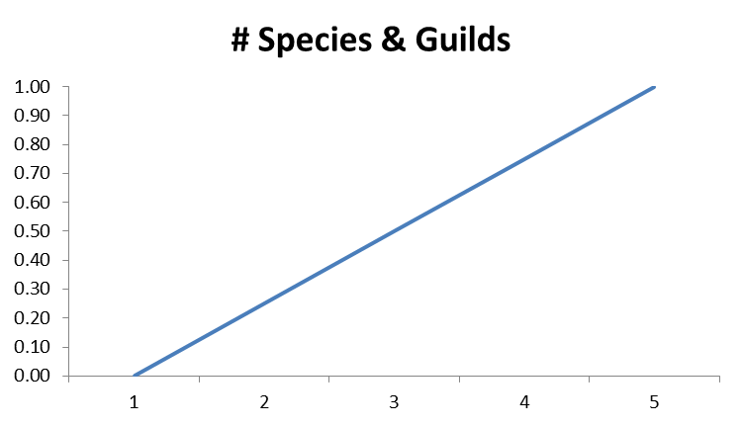Process(es) studied affects no priority species or species groups
2. Process(es) affects 1 – 3 species and at least one species group
3. Process(es) affects 4 – 8 species and at least two species groups
4. Process(es) affects 8 – 12 species and at least three species groups
5. Process(es) affects >12 species and >3 species groups

*Create species groups to reduce overdominance of one taxa eg waterfowl or warblers…..

**2. How much would the study reduce uncertainty in the ability to predict avian population dynamics in the GOM?** *[Constructed Scale]*

**Score Description**

1. 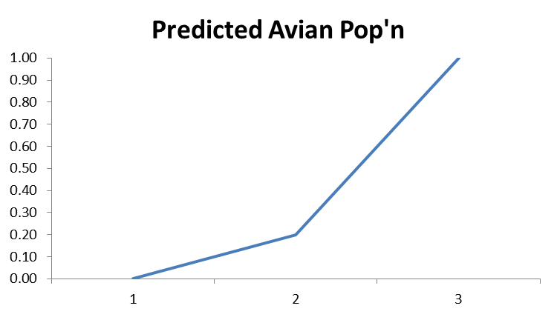Study does not reduce uncertainty in predicting avian population dynamics
2. Study addresses one or more proposed ecological processes but does not show promise for reducing uncertainty in predicting population dynamics.
3. Study addresses one or more ecological processes and shows promise for reducing uncertainty in conjunction with other or with future studies.
4. Study addresses multiple ecological processes and shows promise for reducing uncertainty in prediction of avian population dynamics as a standalone study.

**MANAGEMENT – SUB-OBJECTIVES**

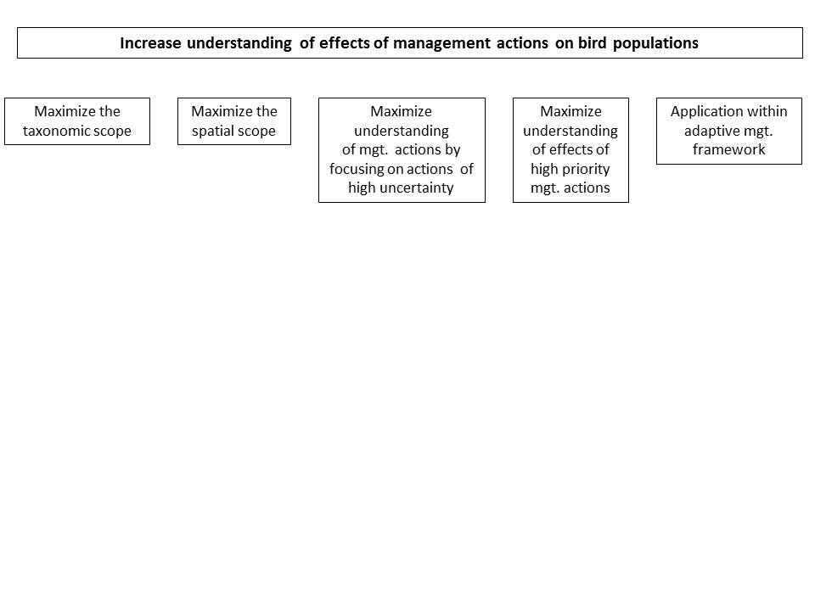**MANAGEMENT**

1. **Maximize monitoring of management practices for priority species. *Emphasis placed on monitoring management practices with broad taxonomic scope (maximum number of priority species).***

The performance metric is based on the number of priority species that a given management practice will impact.

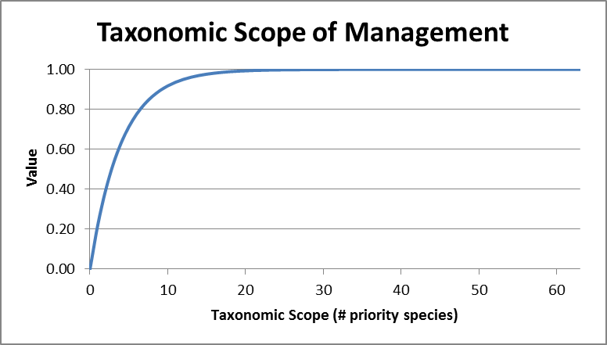

1 = management practice being monitored impacts one priority bird species

2 = management practice being monitored impacts two priority bird species

…

63 = management practice being monitored impacts all 63 priority bird species

Each management practice on the Gulf of Mexico Bird Management Practices List (Table 1) was scored for its potential to impact priority species. The performance metric is the sum of the number of priority bird species that would benefit from a given management practice. The lowest possible score is 0 species and the maximum possible score is 63 species (the number of Gulf bird species identified as priority species).

The value function (Fig. 1) is curvilinear and reaches full value when a management practice benefits approximately 20 priority species.

Figure 1. Value function for the sub-objective “maximize taxonomic scope” of management practices for priority species. The score on the performance metric (x-axis) is the number of priority species that may benefit from a particular management practice.

1. **Maximize monitoring of management practices with broad spatial scope (applicability of management actions). *Emphasis placed on monitoring management actions that have the potential to be broadly applied across the planning region.***

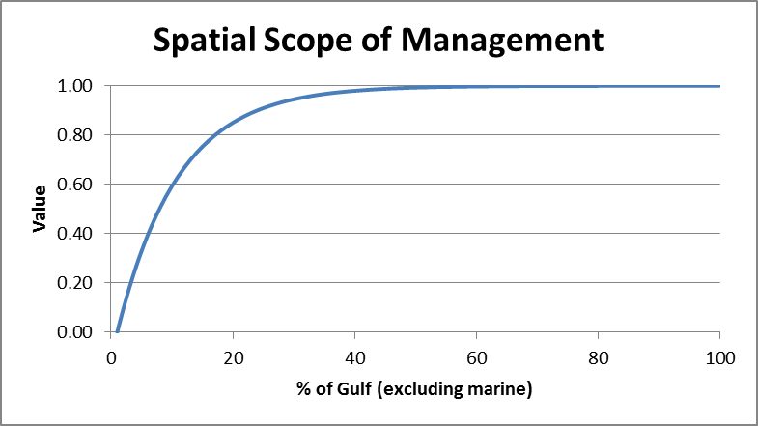

1 = management practice being monitored is relevant in 1% of the planning region

2 = management practice being monitored is relevant in 2% of the planning region

…

100 = management practice being monitored is relevant in 100% of the planning region

The performance metric is based on percentage of the planning region to which the management practice applies. Each management practice on the Gulf of Mexico Bird Management Practices List (Table 1) is associated with a particular habitat. For each management practice, we determine the spatial extent (hectares) of the associated habitat(s) and the proportion of the planning region in which the management practice(s) is relevant (hectares where management is relevant/hectares in the planning region). These calculations will require GIS analysis (to be conducted).

The range of the performance metric is 1 – 100; the maximum value, 100, is used for management practices that are relevant in the entire planning region.

The value function (Fig. 2) is curvilinear and reaches full value at approximately 20% of the planning area.

Note that the shape of the value function may change after the GIS analysis to determine the extent of each habitat.

Note that given the vast extent of marine habitat, this approach will be modified when determining value of management practices in the marine habitats.

Figure 2. Value function for the sub-objective “maximize spatial scope” of management practices. Score on the performance metric (x-axis) is determined by the extent of the GOM planning region in which the management practice could be applied.

1. **Minimize uncertainty about bird population response to management. *Emphasis placed on monitoring management practices of high uncertainty, i.e. management practices for which changes in vital rates (survival and reproduction) are not well understood.***

Level of uncertainty is measured by the amount of peer-review and gray literature devoted to understanding the response of bird populations to management practices on the GOM Bird Management Practices List (Table 1). Uncertainty about management practices is characterized using a constructed scale with three levels: low, medium, and high uncertainty. Scores for each management practice were determined using literature searches with the Google Scholar search engine (Table 2).

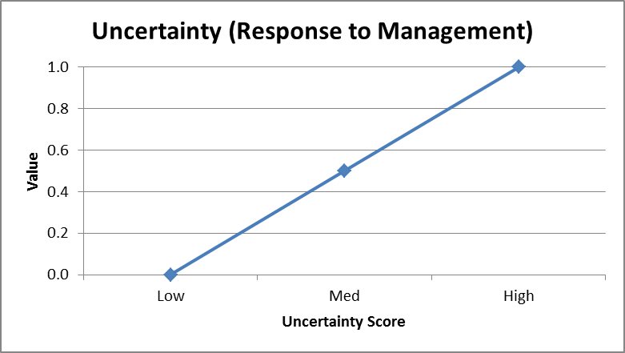

The value function (Fig. 3) increases from “low” to “high” levels of uncertainty.

Figure 3. Value function for the sub-objective “minimize uncertainty” about how bird populations respond to management practices. The performance metric (x-axis) is a constructed scale with three levels of uncertainty: low, medium, and high. Scores on the performance metric are determined by a literature search using the Google Scholar search engine.

1. **Maximize understanding of high priority management practices. *Emphasis placed on monitoring management practices that are currently applied in the Gulf of Mexico region****.*

The performance metric is determined by the number of times that a management practice (Table 1) occurs in the Deepwater Horizon Project Tracking database.

|  |  |
| --- | --- |
| Performance metric for the sub-objective “maximize understanding of high priority management practices | |
| Score | Description |
| Zero | Management practice has zero occurrences in the Deepwater Horizon Project Tracking database (DWHPT); not currently being funded in the GOM region. |
| One | Management practice has one occurrence in the DWHPT database; currently being funded at a low level in the GOM region. |
| Multiple | Management practice has multiple occurrences in the DWHPT database; currently being funded in the GOM region. |

The value function (Fig. 4) is linear and increased from “zero” to “multiple” and reaches full value at “multiple”.

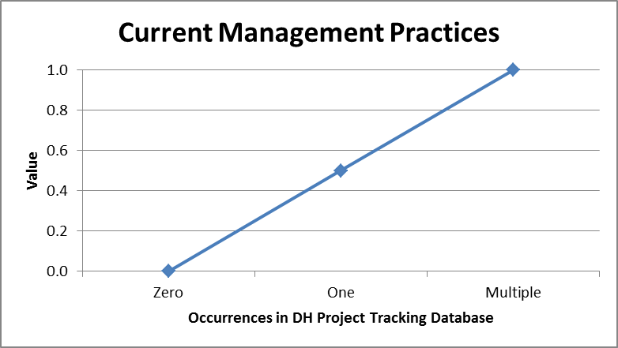

Figure 4. Value function for the sub-objective “maximize monitoring of current management practices”. Scores on the performance metric (x-axis) are determined by the frequency with which a management practice occurs in the Deepwater Horizon Project Tracking database: zero = no occurrences in the project tracking database; one = one occurrence in the database; multiple = multiple occurrences in the database.

1. **Maximize monitoring management practices that are applied in the context of adaptive management. *Emphasis placed on monitoring management practices in the context of adaptive management to facilitate learning about the response to management and informing management decisions****.*

The performance metric is based on consistency with a standard definition of adaptive management. For monitoring to be consistent with the principles of adaptive management, several conditions must be met: 1) the management practice is associated with an iterated decision, which provides opportunity to apply what is learned to future decisions; 2) monitoring is linked to explicit management objective(s) and a set of management alternatives to achieve the management objective(s); 3) decision maker and other stakeholders have identified a key uncertainty that impedes decision making (if there is no uncertainty about management, there is no need for adaptive management); 4) monitoring is associated with a model or set of models (hypotheses) of the system that can be used to predict consequences of management practices; and 5) an explicit process for updating model (hypothesis) weights.

The performance metric is a constructed scale with two levels:

0 = monitoring is not consistent with the principles of adaptive management

1 = monitoring is consistent with the principles of adaptive management

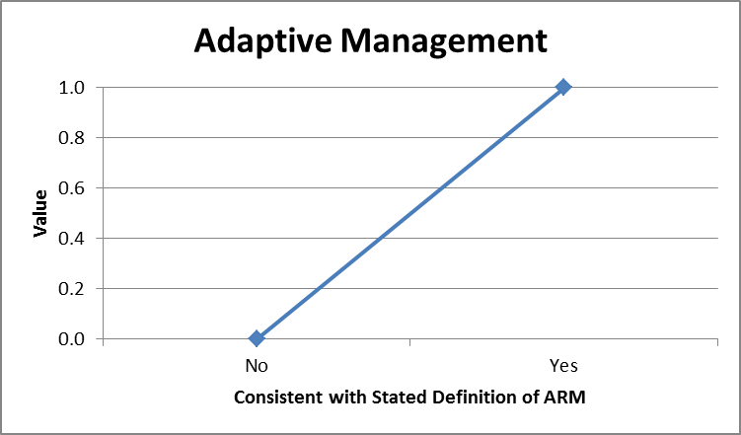The value function (Fig. 5) provides full value to monitoring that is placed in the context of adaptive management.

Figure 5. Value function for the sub-objective “maximize monitoring of management practices in the context of Adaptive Resource Management”. Scores on the performance metric (x-axis) are determined by consistency with the definition of Adaptive Resource Management (see text).

|  |
| --- |
| Table 1. Gulf of Mexico Bird Management Practices List (last update: 2015-07-23) |

Artificial nest construction--Beach/Dune

Artificial nest construction--Cultivated Crops

Artificial nest construction--Estuarine Emergent Wetland

Artificial nest construction--Estuarine Forested Wetland

Artificial nest construction--Grassland/Herbaceous

Artificial nest construction--Open Water

Artificial nest construction--Palustrine Emergent Wetland

Artificial nest construction--Palustrine Forested Wetland

Artificial nest construction--Pasture/Hay

Barrier Island Creation--Beach/Dune

Disease/pathogen/parasite management--Beach/Dune

Disease/pathogen/parasite management--Cultivated Crops

Disease/pathogen/parasite management--Deciduous Forest

Disease/pathogen/parasite management--Estuarine Emergent Wetland

Disease/pathogen/parasite management--Estuarine Forested Wetland

Disease/pathogen/parasite management--Evergreen Forest

Disease/pathogen/parasite management--Grassland/Herbaceous

Disease/pathogen/parasite management--Mixed Forest

Disease/pathogen/parasite management--Open Water

Disease/pathogen/parasite management--Palustrine Emergent Wetland

Disease/pathogen/parasite management--Palustrine Forested Wetland

Disease/pathogen/parasite management--Pasture/Hay

Disease/pathogen/parasite management--Scrub/Shrub

Dredge spoil island creation--Beach/Dune

Ecosystem restoration--Beach/Dune

Ecosystem restoration--Deciduous Forest

Ecosystem restoration--Estuarine Emergent Wetland

Ecosystem restoration--Estuarine Forested Wetland

Ecosystem restoration--Evergreen Forest

Ecosystem restoration--Grassland

Ecosystem restoration--Mixed Forest

Ecosystem restoration--Open Water

Ecosystem restoration--Palustrine Emergent Wetland

Ecosystem restoration--Palustrine Forested Wetland

Ecosystem restoration--Scrub/Shrub

Fisheries management--Beach/Dune

Fisheries management--Estuarine Emergent Wetland

Fisheries management--Estuarine Forested Wetland

Fisheries management--Open Water

Fisheries management--Palustrine Emergent Wetland

Fisheries management--Palustrine Forested Wetland

Harvest management for game species--Beach/Dune

Harvest management for game species--Cultivated Crops

Harvest management for game species--Deciduous Forest

Harvest management for game species--Estuarine Emergent Wetland

Harvest management for game species--Estuarine Forested Wetland

Harvest management for game species--Evergreen Forest

Harvest management for game species--Grassland

Harvest management for game species--Mixed Forest

Harvest management for game species--Open Water

Harvest management for game species--Palustrine Emergent Wetland

Harvest management for game species--Palustrine Forested Wetland

Harvest management for game species--Pasture/Hay

Harvest management for game species--Scrub/Shrub

Integrated predator control for beach-nesting birds--Beach/Dune

Integrated predator control for beach-nesting birds--Estuarine Emergent Wetland

Integrated predator control for beach-nesting birds--Open Water

Prescribed Fire--Deciduous Forest

Prescribed Fire--Estuarine Emergent Wetland

Prescribed Fire--Evergreen Forest

Prescribed Fire--Grassland/Herbaceous

Prescribed Fire--Mixed Forest

Reduce disturbance to beach-nesting birds--Beach/Dune

Reduce disturbance to beach-nesting birds--Estuarine Emergent Wetland

Reduce disturbance to nesting raptors--Deciduous Forest

Reduce disturbance to nesting raptors--Evergreen Forest

Reduce disturbance to nesting raptors--Palustrine Forested Wetland

Reduce disturbance to waterbirds --Beach/Dune

Reduce disturbance to waterbirds --Estuarine Emergent Wetland

Reduce disturbance to waterbirds --Estuarine Forested Wetland

Reduce disturbance to waterbirds --Open Water

Reduce disturbance to waterbirds --Palustrine Forested Wetland

Removal of invasive species--Beach/Dune

Removal of invasive species--Deciduous Forest

Removal of invasive species--Estuarine Emergent Wetland

Removal of invasive species--Estuarine Forested Wetland

Removal of invasive species--Evergreen Forest

Removal of invasive species--Grassland/Herbaceous

Removal of invasive species--Mixed Forest

Removal of invasive species--Open Water

Removal of invasive species--Palustrine Emergent Wetland

Removal of invasive species--Palustrine Forested Wetland

Removal of invasive species--Scrub/Shrub

Sustainable agriculture--Cultivated Crops

Sustainable agriculture--Pasture/Hay

Sustainable aquaculture--Estuarine Emergent Wetland

Sustainable aquaculture--Estuarine Forested Wetland

Sustainable aquaculture--Open Water

Sustainable aquaculture--Oyster Reefs

Sustainable aquaculture--Palustrine Emergent Wetland

Sustainable aquaculture--Palustrine Forested Wetland

Sustainable forestry--Deciduous Forest

Sustainable forestry--Evergreen Forest

Sustainable forestry--Grassland

Sustainable forestry--Palustrine Forested Wetland

Wastewater management--Estuarine Emergent Wetland

Wastewater management--Estuarine Forested Wetland

Wastewater management--Open Water

Wastewater management--Palustrine Emergent Wetland

Wastewater management--Palustrine Forested Wetland

|  |
| --- |
|  |

|  |  |  |  |
| --- | --- | --- | --- |
| Table 2. Constructed scale used to characterize uncertainty in management practices. Literature searches were conducted using the Google Scholar search engine. Number of hits is the total number of articles found by the search engine (reported with the results of the search by Google Scholar). Number of citations for the top 5 relevant hits was calculated after reviewing the search results and identifying the five most relevant references (hits) and summing the number of citations for each reported by Google Scholar. | | | |
| Score | Definition | Number of hits | Number of citations for top 5 relevant hits |
| Low | Many articles on this management action, with a large number of citations for the top 5 relevant hits; includes articles that evaluate impacts on reproduction and survival; one or more review papers; at least some articles are from the Gulf of Mexico region. | >1000 | >200 |
| Medium | Moderate number of articles, but no review papers; some articles evaluate numerical response to management but few investigations of impacts on reproduction and survival; little information specific to GOM region. | 100-1000 | 50-200 |
| High | Very few articles on this management action, or highly conflicting articles; articles do not evaluate impacts on reproduction and survival; no articles from GOM region. | <100 | <50 |

**INTEGRATION – SUB-OJBECTIVES**

**Add integration sub-objective graphic here**

**INTEGRATION – PERFORMANCE METRICS**

1. Maximize the public sharing of monitoring data. *Emphasis placed on a survey that publicly shares data as broadly and quickly as possible.*

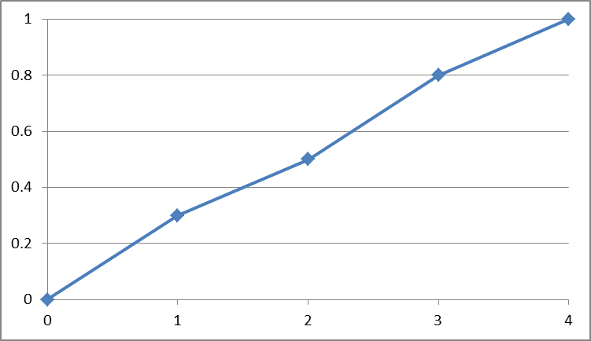0 = No data sharing policy; or only vague reference to sharing data at some point in future

1 = Open or custom restricted access to data within 8 years of project completion (i.e., end date of funding agreement), whether or not included in a central repository

2 = Open access to data within 5 years of project completion, whether or not included in a central repository

3 = Open access to data in a central repository within 2 years of project completion

4 = Data entered directly into a central repository, with open access (exceptions for private lands, threatened & endangered species) within 1 year of project completion

1. Maximize the applicability of data beyond monitoring (e.g., environmental compliance, curriculum development, etc.). *Emphasis placed on a survey that uses data for multiple purposes beyond monitoring.*

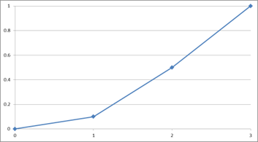0 = No reference to other use of data or information

1 = Alternative uses of information are stated generally

2 = Alternative uses of information are stated clearly but are multiple steps away from intended application (e.g., inclusion in broader scale analyses, pilot study); or intended uses are not realistic or specific

3 = Data and/or research products are clearly stated as being relevant for purposes other than the primary objective in ways that are realistic and specific (e.g., environmental compliance, curriculum development, project evaluation)

1. Maximize the number of established priorities addressed in conservation plans. *Emphasis placed on a survey that addresses multiple priorities stated in conservation plans.*

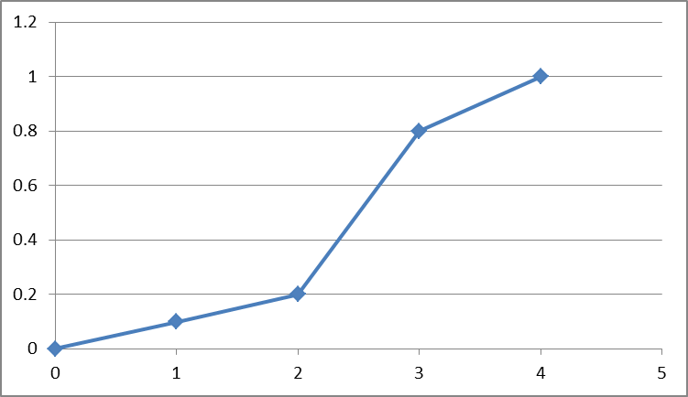0 = No reference to existing plans

1 = Reference to general support of existing plans (e.g., supports State Wildlife Action Plan)

2 = Specific reference to existing plan used to support general priority action (e.g., support monitoring, a priority within the State Wildlife Action Plan)

3 = Specific reference to an existing plan used to support specific priority action (e.g., support monitoring of seaside sparrows, as identified as a priority need in State Wildlife Action Plan)

4 = Specific reference to multiple existing plans used to support specific priority action (e.g., support monitoring of seaside sparrows, as identified as a priority need in State Wildlife Action Plan and JV Plan)

1. 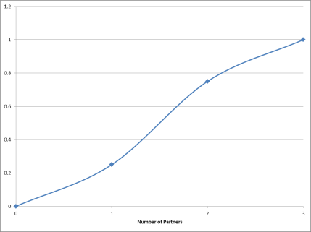Maximize the number of partners (i.e., any collaborators, regardless of funding support) involved in the project. *Emphasis placed on a survey that incorporates different and varied partners in a monitoring survey.*

0 = An individual submission

1 = 1 collaborating agency, organization, or institution

2 = 2-5 collaborating agencies, organizations, or institutions

3 = >5 collaborating agencies, organizations, or institutions

1. 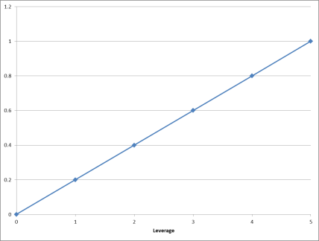Maximize the leveraging for the project. *Emphasis placed on a survey that uses leveraging to support the project.*

0 = No match

1 = 0-25%

2 = 26-50%

3 = 51-100%

4 = 101-150%

5 = >151%

1. Maximize the standardization of proposed surveys.

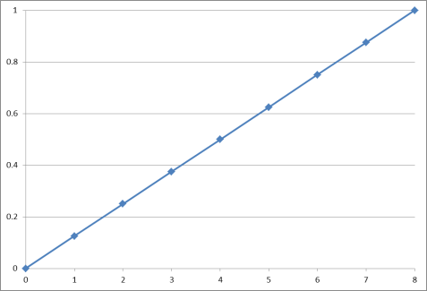0-8 = composite performance metric that is a linear function incorporating standardization associated with:

* Existing habitat classification schemes (1pt)
* Survey protocols (2pts)
* Data repository (2pts)
* Mapping reference system (2pts)
* Code Repository (1pt)
* Ground trothing (1pt)

Note: all standardization components are binary functions

1. Monitoring program alignment (administrative and/or ecological efficiencies). Emphasis placed on monitoring efforts that are aligned with monitoring programs for other non-bird taxa or other physical attributes (e.g., water, habitat, etc.).

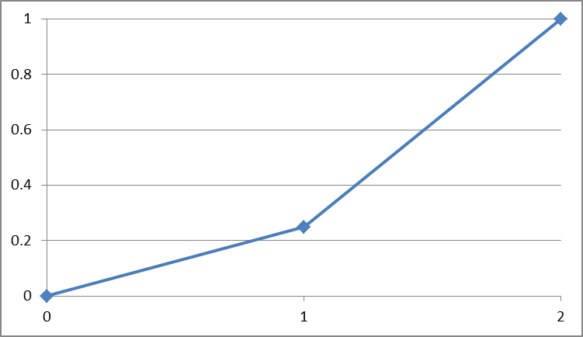

0 = No alignment

1 = Benefits of monitoring program alignment stated generally

2 = Benefits of monitoring program alignment stated explicitly

**RIGOR – SUB-OBJECTIVES**

Add Rigor sub-objective graphic here

**RIGOR – PERFORMANCE METRICS**

1. Clear statement of the project objectives and/or hypotheses. *Emphasis placed on a survey that clearly states objectives and/or hypotheses along with supporting details.*

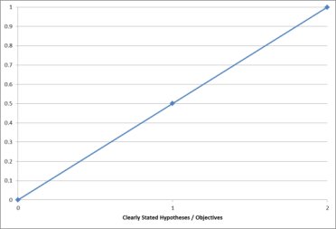0 = No objectives and/or hypotheses clearly stated; or objectives are inappropriate to answer research questions

1 = Objectives and/or hypotheses stated generally; and objectives appropriate to answer research questions

2 = Specific objectives and/or hypotheses stated explicitly with documentation of assumptions; and objectives appropriate to answer research question

1. Maximize the survey design to achieve project objectives. *Emphasis placed on a survey and sampling design clearly appropriate to achieve objectives.*

0 = No reference to survey and sampling design or clearly inappropriate

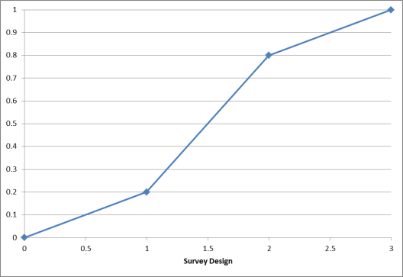1 = Survey and sampling design(s) may be appropriate to achieve objectives but difficult to assess (e.g., not widely used, well-documented, or proven; confusing; seemingly poor fit)

2 = Survey and sampling design(s) likely to be appropriate to achieve objectives (e.g., not widely used, well-documented, or proven but seemingly sound); desired effect size explicitly stated; effect size meaningful ecologically and to management decisions

3 = Survey and sampling design(s) clearly appropriate to achieve objectives (e.g., widely used, well-documented, proven, proper spatial and temporal scales and resolution); desired effect size explicitly stated; effect size meaningful ecologically and to management decisions; formal power analysis conducted

1. Maximize appropriateness of target taxa. *Emphasis placed on a survey that uses most appropriate target species for evaluating objectives and hypotheses.*

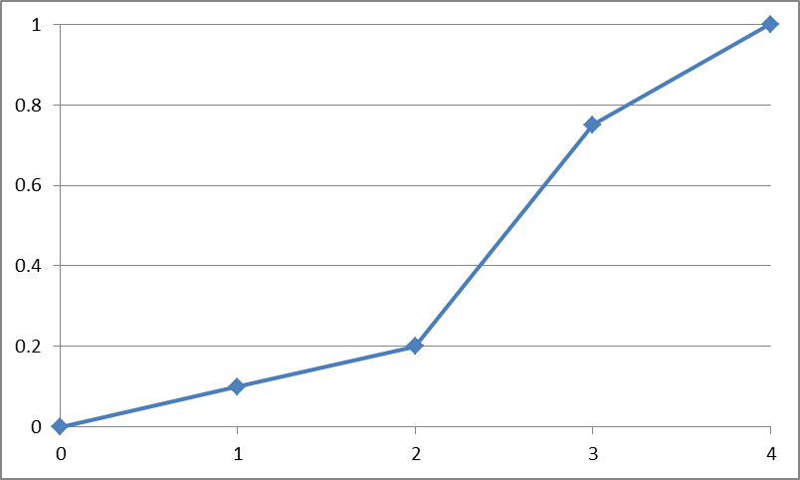0 = Target species not identified or are clearly inappropriate for evaluating monitoring effort's objectives and/or hypotheses

1 = Appropriateness of target species for evaluating monitoring effort's objectives and hypotheses uncertain; seemingly inappropriate

2 = Appropriateness of target species for evaluating monitoring effort's objectives and hypotheses uncertain

3 = Target species will address monitoring effort's objectives and hypotheses - but are not most appropriate (e.g., other species would offer greater insights due to some life history characteristic)

4 = Target species are most appropriate species for evaluating the monitoring effort's objectives and hypotheses

1. Maximize appropriateness of response variable(s). *Emphasis placed on a survey that uses the most appropriate and best suited response variable(s) to address project objectives & hypotheses.*

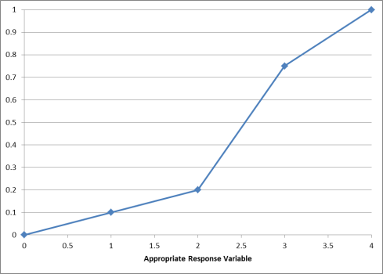0 = No response variable identified or clearly inappropriate to address monitoring effort's objectives and/or hypotheses

1 = Appropriateness of response variable for evaluating monitoring effort's objectives and hypotheses uncertain; seemingly inappropriate

2 = Appropriateness of response variable for evaluating monitoring effort's objectives and hypotheses uncertain

3 = Response variable appropriate but not best suited for addressing monitoring effort's objectives and/or hypotheses

4 = Response variable clearly appropriate and best suited for addressing monitoring effort's objectives and/or hypotheses

1. 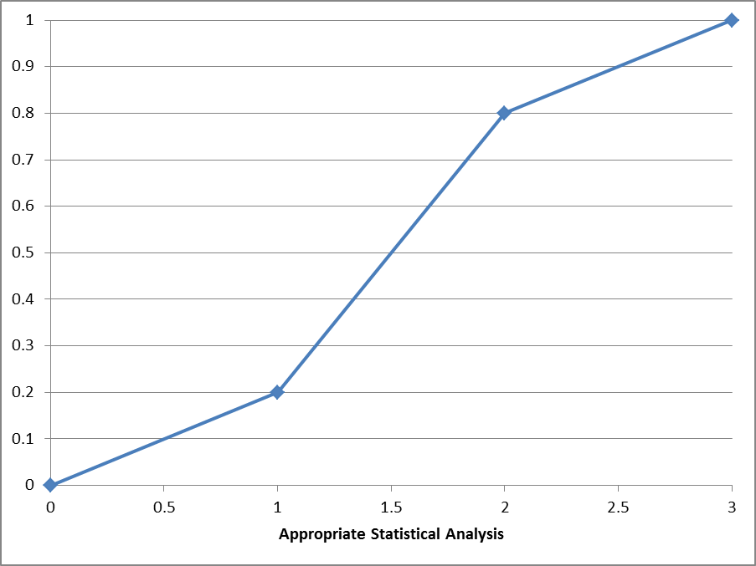Maximize appropriateness of the statistical analysis. *Emphasis placed on a survey that uses statistical methods(s) that are well-described and appropriate.*

0 = No reference to statistical analysis or clearly inappropriate

1 = Statistical analysis may be appropriate to achieve objectives but difficult to assess (e.g., not widely used, well-documented, or proven; confusing; seemingly poor fit)

2 = Statistical analysis likely to be appropriate to achieve objectives (e.g., not widely used, well-documented, or proven but seemingly sound)

3 = Statistical analysis clearly appropriate to achieve objectives (e.g., widely used, well-documented, proven)

1. Develop and articulate a data management plan. *Emphasis placed on a survey that includes a data management plan that addresses data acquisition, development, storage, and transfer.*

0 = No reference to data management

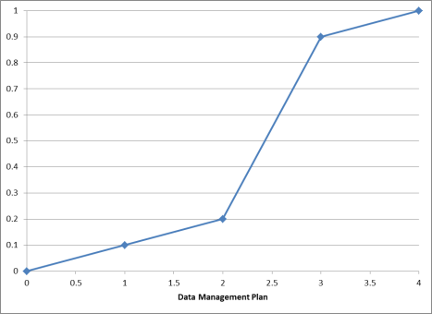1 = General recognition of data management, but lack of specifics

2 = Data management plan incomplete

3 = No data management plan completed, but acquisition, development, storage, and transfer of data addressed; adheres to metadata standards

4 = Data management plan completed; addresses acquisition, development, storage, and transfer of data; adheres to metadata standards

1. Maximize the budget. *Emphasis placed on a survey that has an appropriate, reasonable, and efficient budget to address objectives/hypotheses.*

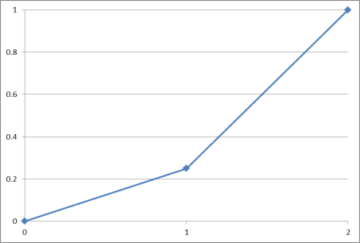0 = No budget or completely unreasonable budget; orders of magnitude off

1 = Budget seems unreasonable to address stated objectives and/or hypotheses; >50% off from what reviewer thinks work should cost

2 = Budget appropriate and reasonable to address stated objectives and/or hypotheses.

1. Optimize the timeline for the project. *Emphasis placed on a survey that has an appropriate and reasonable timeline to address objectives/hypotheses.*

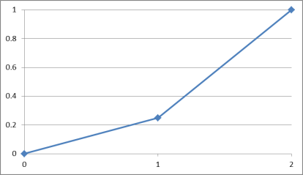

0 = No timeline or completely unreasonable timeline

1 = Timeline generally outlined

2 = Timeline specific, appropriate and reasonable

**Objective Weighting**

Multi-criteria decision analysis requires that decision makers rank or weight multiple objectives according to their preferences. To determine the relative preference for each of our objectives across the members of the Working Group we employed a modified Delphi method to elicit and refine objective weights. The Delphi method was developed as systematic way to develop group judgment for a particular decision by a group of experts (Dalkey and Helmer 1963). A modified Delphi approach is an iterative, facilitated process in which the participants answer survey questions and then review, discuss, and revise their answers until agreement is reached. Thus, a Delphi approach relies on collective knowledge of experts and attempts to transform the opinion of the group into a consensus (Hasson et al. 2000) or to improve performance of estimates (i.e., reduce response variance). Although the Delphi method can be used to arrive at a consensus for an entire decision problem (Hsu and Sandford 2007), here we used it only to elicit objective weights from Working Group members. Furthermore, we did not require participants to reach a consensus, but instead used statistical averages of their responses (Landeta 2006) after set number of elicitation iterations.

During our December 2014 meeting in Rockport, TX we completed an exercise to elicit the relative preferences of our objectives from meeting participants. These preferences were then converted into objective weights. The exercise consisted of asking the group of experts (*i.e.* Working Group members) to quantify individually and anonymously their preference among the objectives. Due to the difficulty of assigning relative preference values to a large number of objectives, the exercise was completed for groups of objectives at each level in the objectives hierarchy (Fig. 1). We used a global scaling procedure (Monat 2009), and experts were asked to use their empirical knowledge of the full (*i.e.* global) range of possible values a future set of decision alternatives could take when considering their preferences. The full range of performance metric values for an objective is an important consideration when assigning preference weights relative to other objectives in the decision problem. Participants were first asked to rank each of objective within a specified group of objectives at a given level of the hierarchy (*e.g*. relevance of the monitoring data and rigor of the monitoring data were ranked relative to each other), with the most important objective being listed as Rank 1, second most important as Rank 2, etc. Ties were permitted. Group participants were then asked to rate the objectives under the following guidelines: a rate of 100 was to be given to any objective listed as Rank 1, subordinately ranked objectives were to be given a rate value that represented their preference for that objective relative to the Rank 1 objective. This process was performed at each level of the hierarchy until all objectives were ranked and rated.

The compiled results of these objective preferences were then reviewed with meeting participants, while maintaining the anonymity of the ranks and rates. Participants were also given a basic statistical summary of the group scores (mean, range, and variance) to provide metrics on the degree of similarity and differences among individuals. Each level of the hierarchy was reviewed in turn, allowing a discussion and clarification of participants’ understanding of the objectives and the opportunity to explain their preference scores. After this exchange, a second round of elicitations was conducted, in which experts could consider the discussions to revise their ranks and rates, if desired. Finally, preference scores were averaged and used to calculate weights for the full set of objectives.  
  
An objective weight was calculated as the proportion of mean preference for all objectives within a given grouping (i.e., for all members grouped below a higher-order objective):

where is the weight for objective *i* within objective group *g*, and is the averaged preference score. Weights sum to 1 for each group but are then modified proportionally by the weight attributed to the objective at the next highest level of the hierarchy. In this manner, the contribution of all objectives at the lowest hierarchical level also sum to 1, reflecting the relative importance of the lowest-order fundamental objectives to the entire decision problem. The process to elicit object weights was transparent, understandable, and replicable if the need arises.

Dalkey, N., and O. Helmer. 1963. An experimental application of the Delphi method to the use of experts. Management Science 9:458–467.

Hasson, F., S. Keeney, and H. McKenna. 2000. Research guidelines for the Delphi survey technique. Journal of advanced nursing 32:1008–1015.

Hsu, C.-C., and B. Sandford. 2007. The Delphi technique: Making sense of consensus. Practical Assessment, Research, & Evaluation 12:1–8.

Landeta, J. 2006. Current validity of the Delphi method in social sciences. Technological Forecasting and Social Change 73:467–482.

Monat, J. P. 2009. The benefits of global scaling in multi-criteria decision analysis. Judgment and Decision Making 4:492–508.

Appendix 1. Geographical boundary used to define bird monitoring objectives and priorities in the Northern Gulf of Mexico.

The geographic extent of the Gulf of Mexico Avian Monitoring Network is bounded on the gulf side by the southern edge of the Marine Bird Conservation Region (BCR) 20 (United States, Gulf of Mexico) with the inland extent (northern boundary) defined by the RESTORE Act [i.e., individual state Coastal Zone Management Act (1972) boundary], plus a 40.23 km (25 mi) inland buffer. The western-southwestern extent of the geography includes that area extending inland (CZM + 40.23 km) near Brownsville, Texas and the east-southeastern extent is defined by the Florida Water Management District boundaries (Florida Department of Environmental Protection) excluding the Northeast Florida Water Management District. For additional information regarding Marine BCR 20, CZM and CZM state boundary definition, and the Florida Water Management District boundary definitions, respectively, refer to the following links: <http://www.bsc-eoc.org/research/gislab/index.jsp?targetpg=bcr>, <http://coast.noaa.gov/czm/act/?redirect=301ocm> and <http://www.dep.state.fl.us/secretary/watman/>.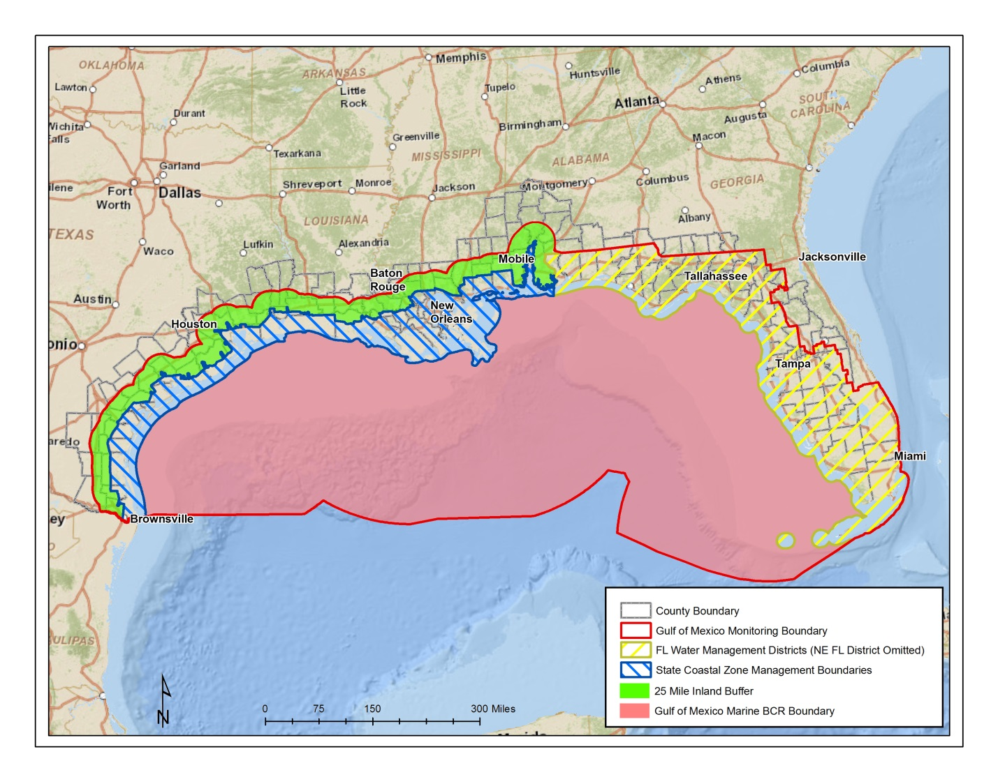

Appendix 2. Priority birds used in defining Northern Gulf of Mexico bird monitoring objectives and priorities.

This list needs to be updated

|  |  |  |
| --- | --- | --- |
| **Common Name** | **Scientific Name** | **Species Group** |
| Bachman's Sparrow | Aimophila aestivalis | Landbird |
| Cape Sable Seaside Sparrow | Ammodramus maritimus mirabilis | Landbird |
| Cerulean Warbler | Dendroica cerulea | Landbird |
| Florida Grasshopper Sparrow | Ammodramus savannarum floridanus | Landbird |
| Florida Scrub Jay | Aphelocoma coerulescens | Landbird |
| Henslow's Sparrow | Ammodramus henslowii | Landbird |
| Kentucky Warbler | Oporornis formosus | Landbird |
| Loggerhead Shrike | Lanius ludovicianus | Landbird |
| Mangrove Cuckoo | Coccyzus minor | Landbird |
| Northern Bobwhite | Colinus virginianus | Landbird |
| Painted Bunting | Passerina ciris | Landbird |
| Prothonotary Warbler | Protonotaria citrea | Landbird |
| Red-cockaded Woodpecker | Picoides borealis | Landbird |
| Red-headed Woodpecker | Melanerpes erythrocephalus | Landbird |
| Seaside Sparrow | Ammodramus maritimus | Landbird |
| Stennett's Seaside Sparrow | Ammodramus maritimus (stennettii?) | Landbird |
| Swainson's Warbler | Limnothlypis swainsonii | Landbird |
| White-crowned Pigeon | Patagioenas leucocephala | Landbird |
| Wood Thrush | Hylocichla mustelina | Landbird |
| Worthington's Marsh Wren | Cistothorus palustris griseus | Landbird |
| American Bittern | Botaurus lentiginosus | Marshbird |
| Black Rail | Laterallus jamaicensis | Marshbird |
| Clapper Rail | Rallus crepitans | Marshbird |
| King Rail | Rallus elegans | Marshbird |
| Least Bittern | Ixobrychus exilis | Marshbird |
| Limpkin | Aramus guarauna | Marshbird |
| Mangrove Rail | Rallus longirostris | Marshbird |
| Yellow Rail | Coturnicops noveboracensis | Marshbird |
| Audubon's Shearwater | Puffinus lherminieri | Pelagic Seabird |
| Black-capped Petrel | Pterodroma hasitata | Pelagic Seabird |
| Brown Noddy | Anous stolidus | Pelagic Seabird |
| Great Shearwater | Puffinus gravis | Pelagic Seabird |
| Leach's Storm-Petrel | Oceanodroma leucorhoa | Pelagic Seabird |
| Magnificent Frigatebird | Fregata magnificens | Pelagic Seabird |
| Northern Gannet | Morus bassanus | Pelagic Seabird |
| Sooty Tern | Sterna fuscata | Pelagic Seabird |
| Wilson's Storm-Petrel | Oceanites oceanicus | Pelagic Seabird |
| Aplomado Falcon | Falco femoralis | Raptor |
| Bald Eagle | Haliaeetus leucocephalus | Raptor |
| SE American Kestrel | Falco sparverius paulus | Raptor |
| Swallow-tailed Kite | Elanoides forficatus | Raptor |
| Black Skimmer | Rynchops niger | Seabird |
| Brown Pelican | Pelecanus occidentalis | Seabird |
| Common Loon | Gavia immer | Seabird |
| Gull-billed Tern | Sterna nilotica | Seabird |
| Laughing Gull | Leucophaeus atricilla | Seabird |
| Least Tern | Sterna antillarum | Seabird |
| Royal Tern | Sterna maxima | Seabird |
| Sandwich Tern | Sterna sandvicensis | Seabird |
| American Oystercatcher | Haematopus palliatus | Shorebird |
| Buff-breasted Sandpiper | Tryngites subruficollis | Shorebird |
| Marbled Godwit | Limosa fedoa | Shorebird |
| Piping Plover | Charadrius melodus | Shorebird |
| Red Knot | Calidris canutus | Shorebird |
| Snowy Plover | Charadrius alexandrinus | Shorebird |
| Wilson's Plover | Charadrius wilsonia | Shorebird |
| Little Blue Heron | Egretta caerulea | Wadingbird |
| Mississippi Sandhill Crane | Grus canadensis pulla | Wadingbird |
| Reddish Egret | Egretta rufescens | Wadingbird |
| Whooping Crane | Grus americana | Wadingbird |
| Wood Stork | Mycteria americana | Wadingbird |
| Mottled Duck | Anas fulvigula | Waterfowl |
| Northern Pintail | Anas acuta | Waterfowl |

Rule Set for Inclusion:

1. Species occurred on ≥50% of priority bird lists (e.g., State Wildlife Action Plans [Florida, Alabama, Mississippi, Louisiana, and Texas], Joint Ventures [Gulf Coast, East Gulf Coastal Plain], Landscape Conservation Cooperatives [Gulf Coastal Plain, Gulf Coastal Plain and Ozarks, South Atlantic], U.S. Fish and Wildlife Service-Birds of Conservation Concern, Audubon Watch List, North American Wetlands Conservation Act, International Union for Conservation of Nature).
2. True pelagic species occurring in the Northern Gulf of Mexico.
3. Endemic species with narrow-geographic ranges within the Gulf of Mexico region.
4. Top 10 oiled species during the Deepwater Horizon spill in the Northern Gulf of Mexico.